Student Grade Management System Project
Team Members:
- Keera Newcomer
- Mason Underwood
- Jude Phillips

Repository Link:
Link to the repository

Explanation of the program logic:
The Student Grade Management System is a menu-driven program that allows the user to store, retrieve, and analyze student grades efficiently. It uses two parallel 1D arrays, one being for students, and one being for grades. The index positions of each array match the other array, so names[i], and grades[i], will always connect the student’s name with their grade. The program also uses count as a variable to keep track of how many students/grades are in the system.
Once the program starts, the main method creates a StudentGradeManagementSystem object and calls the menuLoop() method. The menu keeps repeating until the user decides to exit the program by choosing choice 6. The menu displays all the features of the system so that the user can choose what they want to do within the system. Depending on what choice the user selects, the program will use if and else if statements to decide which method to call.
When adding a student into the system, the program first checks if the system is full already or not. If not, the user is able to enter a student’s name and their grade. The grade is then checked to make sure it is valid, meaning the value is between 0-100, and if it is, the system will store the student’s name and grade at the next available index in their respective arrays, and then increase count by 1. The count increases so that the next time a student gets added, they are added into the next index position that is empty.
If the user ever tries to do something that is impossible, for example, searching for a student when there are no students in the system, the program handles this by outputting an error message telling the user that there are no students to search for yet. The program handles all cases like this regarding any method or action.
Explanation of major functions/methods used:
main: This is the method that starts the program. It creates a new object called system from the StudentGradeManagementSystem class and then calls the menuLoop() method using that object to start up the menu system for the user to use.
menuLoop(): This method keeps calling the showMenu() method so that the menu for the program gets displayed. Once the menu is displayed to the user, the user is asked to enter the number of their choice that corresponds to the feature they are trying to use that is displayed on the menu. This method uses if and else if statements to decide which method to call depending on the choice that the user inputs. Choices 1-5 will each call different methods, choice 6 will exit the program, and any other choice will result in an error message.
showMenu(): This method is used to display the menu interface for the user. This method is made up of 9 print statements so that once it is called it displays these to the user, and it looks like a menu made up of different features for the user to select from.
addStudent(): This method allows the user to add a student, and that student’s grade, into the Student Grade Management System. This system has a maximum of 50 students, so it first checks if the count is greater than or equal to 50 already. If so, it tells the user that the system is full. Otherwise, once the method is called, the user is asked to enter a student’s name and that student's grade. If the grade is between 0-100, it gets stored into the system using an array called grades[], and if the number is less or more than that, the user receives an error message. Names are stored in an array called names[]. If a student and grade are added successfully, it tells the user it was successful.
displayStudent(): This method is used to display all students and their grades that are currently stored in the Student Grade Management System. First, it checks if the count is equal to 0, which would mean there are no students first. Otherwise, it uses a for loop to go through each index of the arrays up to the current count and prints each student’s name along with their grade.
findStudent(): This method allows the user to search for a specific student and see their grade. It checks if the count is 0 at first to make sure the system isn't empty. If it is empty, the program will print a message telling the user that there are no students to search for. Otherwise, it will loop through the names[] array to find the name that matches the one the user input. The name will match regardless of capitalization because of equalsIgnoreCase(). Once the name entered is matched to a name in the array, it prints the students' name and their grade.
calculateAverage(): This method is used to calculate the average grade of all students in the system. It first checks if there are any grades to calculate by seeing if count is 0. If there are no students, it tells the user to add one first. If there are students, it creates a variable called total and uses a for loop to add up all the grades in the array. After that, it calculates the average by dividing the total by count and casting it to a double so the result can include decimals. Finally, it displays the class average to the user.
findHighestAndLowest(): This method finds the students with the highest and lowest grade in the system. It first checks if there are any students by checking if count is 0. If there are none, it tells the user to add a student first. If there are students, it sets two variables, highestGrade and lowestGrade, to 0, which represent the index positions in the array. It then uses a for loop to compare each grade in the grades array. If it finds a grade higher than the current highest, it updates. Same with the lowestGrade. After the loop finishes, it displays the name and grades of both the highest and lowest students.

Individual contributions:
Code: Mason
Report: Keera
GitHub Creation: Jude

Sample Run Screenshots on Next Page

Screenshots of Sample Runs:
Sample Run 1: Adding Students and Displaying All Records
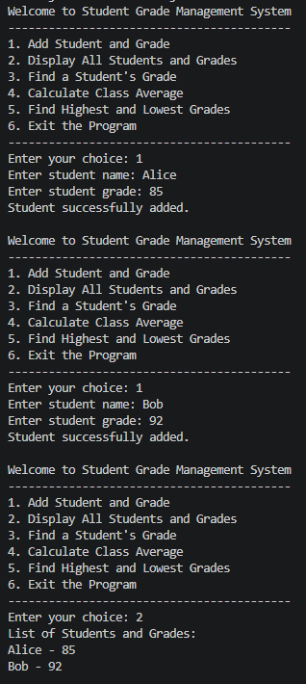

Sample Run 2: Finding a Student’s Grade
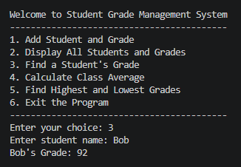

Sample Run 3: Calculating Class Average
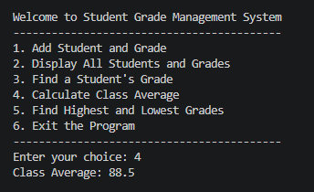

Sample Run 4: Finding Highest and Lowest Grades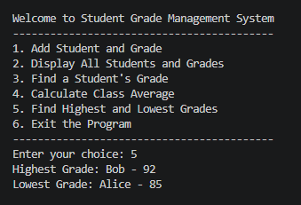
Sample Run 5: Handling Invalid Input
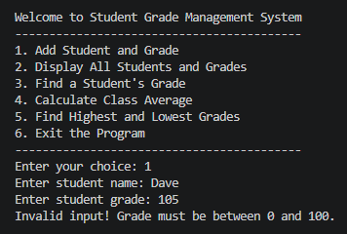

Additional Sample Run: Exiting the Program